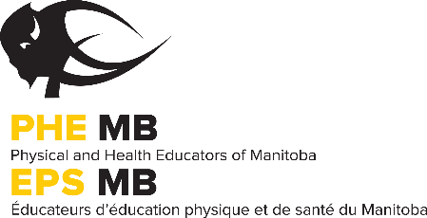
PHE Manitoba MTS Professional Development Day Conference
October 20th, 2017
Exhibitor Marketplace Registration Form

The Physical and Health Educators of Manitoba (formerly MPETA) and the St. James-Assiniboia School Division will be hosting the 2017 MTS Professional Development Day Conference at College Sturgeon Heights Collegiate on October 20th, 2017. The Organizing Committee anticipates that approximately 700 physical education, health education and classroom teachers (from across the province) will attend the conference. The conference will not only provide delegates with professional development and networking opportunities, they will also have time to visit the marketplace where exhibitors will be able to promote their products, programs and services.

There are a limited number of spots available. To confirm your spot, send your registration, prizes and payment in by October 6th, 2017.

Information for Marketplace Exhibitors:
Date: Friday, October 20th, 2017

Time: 7:45 AM – 1:45 PM
The major delegate ‘rushes’ are around registration, morning energy break and lunch. You may leave your exhibit up until after the last break (2:15-2:30 PM) but delegate traffic will be low at this time.

Set Up: Thursday, October 19th, 2017 4:30 – 7:00 PM
Friday, October 20th, 2017 7:00 – 7:45 AM

Location: College Sturgeon Heights Collegiate – 2665 Ness Avenue, Winnipeg, MB
Specific marketplace location details will be available closer to October, 2017.

Fees: For-Profit Organizations $250.00 plus door prize
Not-For-Profit Organizations $60.00 plus door prize

Parking: More information to follow.

- The MTS PD Day Committee is trying to go green, thus, we are not collecting handouts for the delegate bags. We encourage you to have any relevant material at your display table for delegates to pick up over the course of the Marketplace.

- Exhibitors are responsible for the cleanup of their display table. Unused brochures & materials must be removed at take down.

- To book a spot in the 2017 Exhibitor Marketplace at MTS PD Day, complete the registration form and send with payment by October 6th, 2017 to:
PHE Manitoba
319-145 Pacific Avenue,
Winnipeg, MB R3B 2Z6

- Make cheques payable to the Physical and Health Educators of Manitoba (PHE Manitoba)

- Door prize donations (Items or donations accepted at a minimum of 25$ value) must be submitted by October 6th, 2017 to:
PHE Manitoba
Attn: Krystle Seymour
319-145 Pacific Avenue,
Winnipeg, MB R3B 2Z6
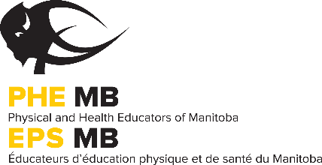
PHE Manitoba MTS Professional Development Day Conference
October 20th, 2017
Exhibitor Marketplace Registration Form

Organization _____Contact Name__________ ______

Mailing Address City

Province Postal Code Phone#

Email Website _______

- Registration - Please check one:
[ ] For-Profit Organizations: $250.00 plus a door prize donation.
Item or donation accepted. Minimum 25$ value.
Identify Door Prize

[ ] Not-For-Profit Organizations: $60.00 plus a door prize donation
Item or donation accepted. Minimum 25$ value.
Identify Door Prize

If you have non-paper based promotional items, such as a magnet or a pen, we would gladly accept this donation at no charge for our delegates.

- Equipment - Indicate the type of equipment you will require in addition to a table and chairs (note - we may not be able to accommodate special equipment requests):

- Power (Limited Spots) ___ Yes ___ No
If yes, please bring an electrical cord.

- Additional space for racks, equipment, etc. ___ Yes ___ No
If yes, indicate the type and approximate size of the space you will need below. We may not be able to accommodate special space requests.

- Special consideration/comments:

- Complete the registration form and send your prize by October 6th, 2017 to:
Mail: PHE Manitoba, 319-145 Pacific Avenue, Winnipeg, MB R3B 2Z6
Email: mpeta@sportmanitoba.ca

- If you have any questions, contact Robert Senecal at rsencal@sjsd.net

