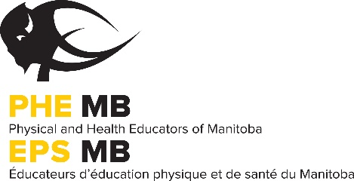
PROFESSIONAL DEVELOPMENT FUNDING APPLICATION FORM

The PHE Manitoba professional development fund was established through constitutional guidelines. Once this amount has been expended, no further monies will be available for PD assistance until the following December. Virtual or in-person activities will be funded to a maximum of $300 (Canadian funds) per year. A maximum of $100 will be funded, if the candidate was funded over $200 in the previous year. Following one year of reduced funding ($100) the applicant will again be eligible for $300.
APPLICATIONS ARE TAKEN ON A ‘FIRST-COME, FIRST-SERVED’ BASIS.
APPLICATIONS MAY BE SUBMITTED NO LATER THAN 2 WEEKS BEFORE AN EVENT.

OBLIGATIONS OF THE APPLICANT
- The applicant must have a FULL membership in good standing for two consecutive years prior to the application. First year teachers are exempt from this clause.
- The conference or workshop applied for must be applicable to physical education or health education.
- The applicant must provide receipts of expenses incurred from the conference or workshop.
- The application must be made prior to the event. Funding requests made after the event will not be considered.
- The applicant must provide an article describing the conference, workshop or session for publication in the PHE Manitoba Journal. Include some practical games, new ideas and/or different activities to share with your colleagues. Be sure to include the details to allow others to replicate the game, idea and/or activity! This must be submitted electronically in Word (PC version) to phemb@sportmanitoba.ca
- Reimbursement of funds will be withheld until journal articles and post event forms are received.

Name School

Mailing Address Division

City Postal Code Phone (w)

Email Fax (w)

____ Yes, I am in my first year of teaching.
____ Yes, I would be willing to share my experience with my colleagues at a workshop.

PROGRAM TITLE / DESCRIPTION (Please attach information on the event.)

Conference/Workshop

Location Dates

ANTICIPATED EXPENSES | AMOUNT | FUNDING | AMOUNT
Registration | $ | PHE Manitoba PD Contribution Request | $
Transportation | $
Food | $ | School Contribution | $
Lodging | $ | Division Contribution | $
Substitute Costs | $ | Your Contribution | $
EXPENSES TOTAL | $ | FUNDING TOTAL | $
Article and receipts must be submitted to the PHE Manitoba office by June 24th, 2022 in order to receive funding. Late submissions will not be accepted.
SEND PD FUNDING REQUEST FORM TO:
PHE Manitoba
319-145 Pacific Avenue - Winnipeg, MB R3B 2Z6 Phone: (204) 926-8357 Email: phemb@sportmanitoba.ca

