What are you Counting On:
Physical Education and Numeracy?
Dr. John Byl
JOHNBYL50@gmail.com www.canadago4sport.com
https://www.canadago4sport.com/numeracy-index
Physical Education has its own curricular expectations. However, some of these expectations can be met or reinforced through other curricular areas, and other curricular areas (with a focus on mathematics) can have some of their expectations met or reinforced in Physical Education Classes. We will demonstrate some of these activities. Be prepared to learn through involvement in these activities.

It is about active and healthy living
https://www.caringbridge.org/visit/drjohnbyl

In-Person Agenda:

Get Rolling with Numeracy
Name | Equipment | Movement | Link
Even and Odd with Wall Sit |  | Run | https://www.canadago4sport.com/Numeracy/Even-and-Odd-With-Wall-Sit-and-Run
True and False | One pool noodle per pair | Run | https://www.canadago4sport.com/Numeracy/True-and-False
Odd Even Tag in pairs | With one dice each and one pool noodle per pair | Run | Need Video
Ankle touch | With one die each | Agility | https://www.canadago4sport.com/Numeracy/Odd-Even-Tag
Odd pick up | Per pair two dice and one foam piece or beanbags | Agility | https://www.canadago4sport.com/Numeracy/Planks-till-odd
Quick Count Relay | With playing cards and popsicle sticks | Run | https://www.canadago4sport.com/Numeracy/Quick-Count-Relay
Ding Dong 7—number higher that two (with pushing down and reach for the sky |  |  | https://www.canadago4sport.com/Numeracy/Ding-Dong-7
21 Pilots |  |  | Need Video
Tag and Add (or divide, multiply) | With pool noodles for ITs and 2 decks of cards | Run | https://www.canadago4sport.com/Numeracy/Tag-and-Add
Most Cards or and 5 Jumping Jacks | Three playing cards each player | Jumping Jacks | Need Video

Get Rolling with Patterns
Name | Equipment | Movement | Link
Paint Palette Relay | With six different coloured poly spots and patterns for each group | Run | https://www.canadago4sport.com/Numeracy/Paint-Pallette-Relay
Connect Four Up | Checker board and pieces | Run | https://www.canadago4sport.com/Numeracy/Connect-Four-Up
Connect Four any ways | Checker board and pieces | Run | Need Video
Quicksand | Tarp and pathway sheets | Teamwork  Walking | https://www.canadago4sport.com/Leadership/Quicksand
Number Sequence | With 6 sequentially numbered playing cards | Run | https://www.canadago4sport.com/Numeracy/Number-Sequence-Relay
Break the Code | Cards numbered 2-9 | Run | https://www.canadago4sport.com/Numeracy/Break-the-Code
RPS Geometric Shapes | Four poly spots to mark the corners and four puzzles—one for each team | Run | https://www.canadago4sport.com/Numeracy/Geometric-Shapes-Gathered-from-a-Square

Numeracy and Patterns with Toppletubes (or plastic cups for some activities)
Name | Equipment | Movement | Link
Topple 10 times—Inhibitory Control (executive functioning) | One Toppletube per group (with side numbers) | Throw | https://www.canadago4sport.com/Target1/StrykeN-the-Pins
Topple over 40--Memory | One Toppletube per group (with side numbers) | Throw | https://www.canadago4sport.com/Target1/StrykeN-the-Pins-to-Over-50
Topple exactly 30—Mental flexibility | One Toppletube per group (with side numbers) | Throw | https://www.canadago4sport.com/Target1/StrykeN-the-Pins-to-Exactly-40
Topple a Specific Number—ie 66 |  | Run | https://www.canadago4sport.com/Numeracy/Topple-Specific-Number
Numbers in Sequence—ie 1-4, 5-8, 9-10 |  | Run | https://www.canadago4sport.com/Numeracy/Topple-Tube-Number-Sequence
Tic Tac Toe Double Three in a Row (relay style with two people each and a spot to start) |  | Run | https://www.canadago4sport.com/Numeracy/Topple-Double-Tic-Tac
Tic Tac Toe Three in a Row no-grid (run or from push-up) |  | Run | https://www.canadago4sport.com/Numeracy/Tic-Tac-Toe%E2%80%94No-Grid-
Topple three up. |  | Run | https://www.canadago4sport.com/Locomotor/Topple-Three-Up
Human Tic Toc with two teams of four | With 12 poly spots—first person goes fifth, and secondly, team decides who moves | Run | https://www.canadago4sport.com/Numeracy/Human-Tic-Tac-Toe-in-Order
Tic Toc Rolling Three in a Row (or four in a row?) | Nine hula hoops and two sets of four different coloured balls | Roll | https://www.canadago4sport.com/Numeracy/Tic-Tac-Toe-Rolling-Three-In-a-Row

Nutrition
Name | Equipment | Movement | Link
Balanced Plate (like Robin’s nest) | Food items (1 fruit, 1 vegetable, 2 grains, 2 protein) and three plates | Run | https://youtu.be/jaTpHWJg4oM
Gather Meals from the Farm (like Geometric shapes) | All foods and 4 poly spots | Run | https://www.canadago4sport.com/Nutrition/Gather-Balanced-Meals-from-the-Farm
Food Run | With threes, all food groups, and one pool noodle per team for taggers | Run | https://www.canadago4sport.com/Nutrition/Food-Run
Active Brain
Name | Equipment | Movement | Link
Simon Says (previous and opposite—with switching sides) |  | Follow Leader | Regular:  https://www.canadago4sport.com/Leadership/Simon-Says  Previous:  https://www.canadago4sport.com/Leadership/Simon-Says-Do-Previous  Opposite:  https://www.canadago4sport.com/Leadership/Simon-Says-Do-Opposite
Ying Yang You (slow, fast, with back) |  | Arm Motions | Slow:  https://www.canadago4sport.com/Leadership/Ying-Yang-You-Slow  Faster:  https://www.canadago4sport.com/Leadership/Ying-Yang-You-Faster  Back:  https://www.canadago4sport.com/Leadership/Ying-Yang-You-Back

- Canadago4sport:
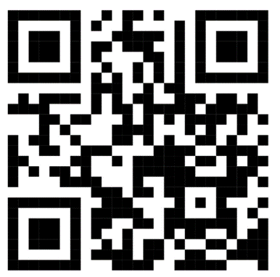
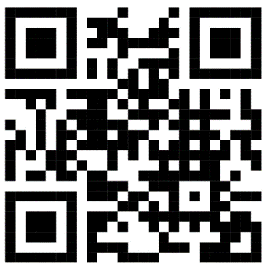
  - 800+ game docs and 350+ game videos
  - www.canadago4sport.com

- Gopher Sport:
  - Order from hundreds of equipment ideas.
  - https://www.gophersport.com/

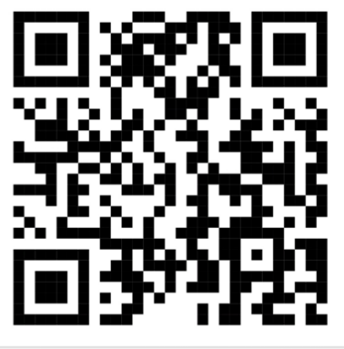
- Twitter & Instagram: Tuesday (sometimes other days) posts
  - Follow at @canadago4sport

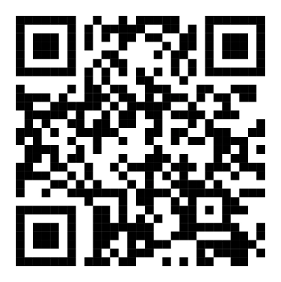
- Pinterest:
  - 26 boards, and 875+ pins
  - Follow at https://www.pinterest.ca/canadago4sport/
- YouTube:
  - 550+ videos
  - Subscribe at https://www.youtube.com/c/canadago4sport/

- Equipment:
  - From Home:
    - Pool Noodles
    - Plenty of dice
    - 2 decks of cards
    - Container of popsicle sticks
    - Paint Palette papers
    - Puzzles—Geometric Shapes in paper
  - From Gopher (NOTE: minus Vinyl Spots ($182) and PEmoji Coated-Foam Balls ($138) for a total of subtracting $320 if Tag workshop is also done (equipment used for both sessions).
 | Item |  | Details | Quantity | Subtotal
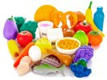 | Molded Vinyl Foods - Molded Vinyl Foods  Item No: 26-103  Availability: Ships Soon | Price:  Unit: | C$114.24  Set of 26 | 1 | C$114.24
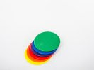 | Rainbow TopSpot Vinyl Spots - Rainbow Set, 5" dia  Item No: 93-022  Availability: In Stock | Price:  Unit: | C$30.42  Set of 6 | 6 | C$182.52
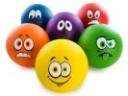 | PEmoji Coated-Foam Balls - PEmoji Coated-Foam Balls  Item No: 72-094  Availability: In Stock | Price:  Unit: | C$138.43  Set of 6 | 1 | C$138.43
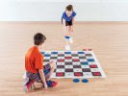 | KingMe! Checkers Set - KingMe! Checkers Set  Item No: 58-578  Availability: Ships Soon | Price:  Unit: | C$252.73  Set | 1 | C$252.73
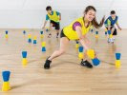 | ACTION! ToppleTubes Set - Regular  Item No: 58-259  Availability: In Stock | Price:  Unit: | C$278.13  Set | 2 | C$556.26
Subtotal: C$1,244.18
Estimated Shipping: C$149.30
Estimated Sales Tax: C$0.00
Total: C$1,393.48

