Intramural Grant Application Form 2023-2024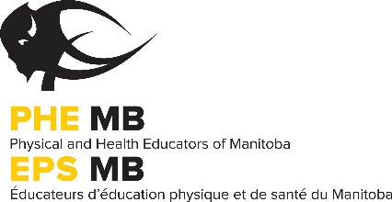

PHE Manitoba is pleased to continue this grant program to be used for the purchasing of non-traditional Intramural Equipment. Please note that equipment used for inter-scholastic activities (basketball, volleyball, hockey…) will not qualify for the grant. There will be 20 grants of up to $300 available for the school year.

CRITERIA
Applicants must:
- Be a full PHE Manitoba member.
- Complete the Intramural Equipment Grant Application Form (below).
  - One grant application per school will be accepted.

Once approved, the applicant will:
- Complete the intramural equipment grant acceptance form.
- Submit the invoice, receipt, or purchase order for the equipment.
- Submit an article for the PHE Manitoba Journal (details below).
  - Funding will be released upon receipt of these items.

This journal article must include the following:
- Equipment description (include a picture if desired).
- Amount of equipment purchased.
- Total cost of equipment (if the cost exceeded the $300 grant, indicate where additional funds came from).
- Where the equipment was purchased from.
- Description of an activity/game that will use the equipment.

INTRAMURAL EQUIPMENT GRANT APPLICATION

I am a member of PHE Manitoba ___Yes ___No*
*If you are not a PHE Manitoba member, please contact the office about purchasing one to be eligible for consideration.

Member Name: Email:

School Grades: Division:

Mailing Address (W): City: Postal Code:

Phone (W): Fax (W):

If our school is approved for the Intramural Equipment Grant Funding, we will purchase:

Equipment Description | Quantity | Cost
Please send completed form to the PHE Manitoba office via email: phemb@sportmanitoba.ca
Article and receipts must be submitted to the PHE Manitoba office by June 23rd, 2024 in order to receive funding. Late submissions will not be accepted.

