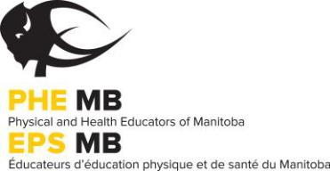
Healthy Schools Loaner Program
School Rental Agreement

School Division: |  | School:
School Mailing Address:
City/Town: | Postal Code: | Phone Number:
Name: | Position: | Email:

Loans are available for a three week loaner period. Please indicate three options for your loan period:

Start Date (Date you wish to have the kit) | End Date (date kit will be returned to PHE Manitoba)

1.

2.

3.

I will be responsible for the return of the Healthy Schools Geocaching Loaner Program Kit on the finish date agreed upon. Schools will not be charged for courier/shipping costs (arrangements will be made with PHE Manitoba).

I am also responsible for the cost of repair or replacement of any GPS unit(s) that is damaged or lost while in my care. Batteries for the GPS unit(s) is the responsibility of the renter.

I allow the name of my school and GPS activity to be published in print and online

Instructor’s Signature: | Date:
Print Instructor’s Name:
Principal’s Signature: | Date:
Print Principal’s Name:

Submit to the Physical and Health Educators of Manitoba (PHE Manitoba):
319-145 Pacific Avenue, Winnipeg, MB R3B 2Z6 Tel: 204-926-8357 Email: phemb@sportmanitoba.ca

