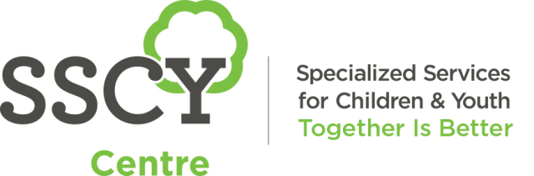
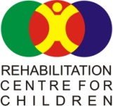

PHE Presentation Oct 2022: “School Based Physiotherapy – Middle and High School Considerations”
Presenter: Megan Carter, School Therapy Services, Rehabilitation Center for Children
Session Goals:
- What is school based physiotherapy?
- How can school physiotherapy help with Phys Ed inclusion? What is our piece / your piece of the challenge?
- Resources?
Role of School Physiotherapy:
Collaborative/Consultative model:
- PTs don’t “treat” in the schools
- Work with the school team (teachers, EAs, resource support) and collaborate with families to determine priorities
- Activity programs are delivered by school supports – primarily EAs
- Physical access to school: classroom, other areas of school (including bathroom or grooming room), playground
- Help determine abilities!
- Functional / play based approach to programming- younger years; Enhance development of fundamental movement skills
- Bring forward medical information as needed, to school (risk factors, restrictions, activity tolerance etc) > Ask if you need to know
- School PT may be an access point to medical system – refer to orthotist, orthopedics (other: genetics, neurologist . .)
- Liaison regarding orthotic devices (teach EAs on/off and monitoring); Role after procedures (like Botox for reduction of spasticity) or surgeries
- PT may be involved with school programs like swimming, skating (PT SJSD runs swim program)
Inclusion in Phys Ed Classes?
- What comes to mind when we say “inclusion”
- What was/is an inclusion challenge you have had in your own teaching experience?

“School Based Physiotherapy – Middle and High School Considerations” Page 2
PHE Presentation Oct 2022

The inclusion challenge:
- Moving to higher grade levels: high focus on fundamental movement skills in elementary school curriculum and then focus shifts to sports skills
- Many students with challenges have still not developed fundamental movement skills by middle school or even high school; the skills gap widens
- Generally less support available for students with challenges to continue with therapy programming in middle and high school
Inclusion considerations:
- What are the goals of the Phys Ed class for a particular student?
  - Skill building (towards what end point?)
  - Socialization time
  - Physical development
- What is the student’s perception of inclusion?
- What aspects might make the student feel more vulnerable?
- Participation in the warm-up at the start of class may be more accessible
- Participation in the skill development part of the class may be more accessible.
- The actual sport or game—how to include the student? (game rules, increased speed of movement etc)
- Alternative activities set up to do with a group of peers, or modifications to a whole group activity?
Collaboration with school PT:
- When we show up at the side of the gym we are not there to judge you!
- Observation helps the PT to see how the student fits in – we are looking for amount of participation, student frustration etc.
- We appreciate your feedback
- Can we plan ahead for curriculum areas ?
Megan Carter
Senior Physiotherapist
School Therapy Services
mcarter@rccinc.ca

“School Based Physiotherapy – Middle and High School Considerations” Page 3
PHE Presentation Oct 2022

RESOURCES:
Already on the PHE Manitoba website:
- Previous presentation from me, 2021 handouts and recording. Lots of info about general role of school PT. Found under “2021 PHE MB MTS PD Day Recordings and Hand Outs”. Presentation title: “Collaborating to optimize Phys Ed experiences for kids with challenges” (session 28)
- Under “session handouts”, another presentation by school PT Sandy Loewen titled “Adapting Physical Education Classes for Students with Additional Needs” – 2019. This is the PowerPoint of her 40 slides; refers to “Moving to Inclusion” and has lots of specific adapted skills suggestions
Other resources: (examples)
- Active Living Alliance for Canadians with a Disability – “Moving to Inclusion Manual” available online
- Accessible Sport Connection Manitoba (ascmanitoba.ca)
- Manitoba Wheelchair Sport Association (mwsa.ca)
MWSA contact person re: school program is Joey call 204-509-1543; fee $100 per day; sport wheelchairs are brought to the school
- Curl Manitoba will come to your school. Student could do “stick” curling to participate with the class in the gymnasium.
To set up a rocks and rings session at your school please contact tewasko@curlmanitoba.org or call 204-925-5723
https://curlmanitoba.org/projects/curling-programs/#1497371908153-06f0b9ac-8d84

